Assignment 1

***Important notes:***

***Exceptional handling should be done where needed.***

***Pictures are just for the reference you can create your own style of webpage except for question 6, question 10***

Q1- Create a webpage that hide a text on the click of a button.

Q2- Create a webpage that changes image on the click of a button.

Q3- Create a webpage that changes the text of a paragraph on the click of a button.

Q4- Create a webpage that alerts a warning “Error” when a button is clicked.

Q5- Create a webpage that toggles a text (show and hide) on the click of a button.

Q6- Write a JavaScript code in which when a user clicks on **Explore** button, the user is directed to Fill your interest page.



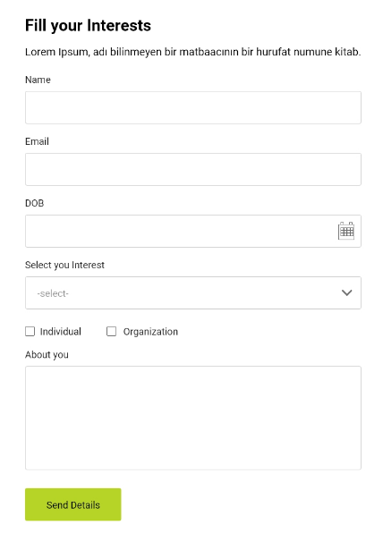

Q7- Create 2 buttons that subtract and add a number from the display.

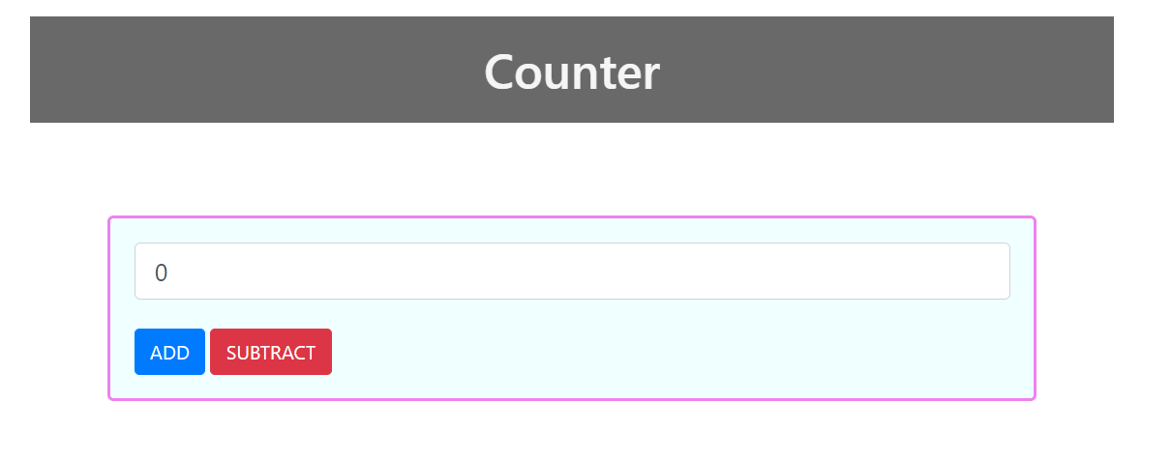

Q8- Create a webpage in which the user inputs First name, Last Name, and Name format(dropdown) ({firstname, lastname} or {lastname, first name}) and then display the name according to the name format.

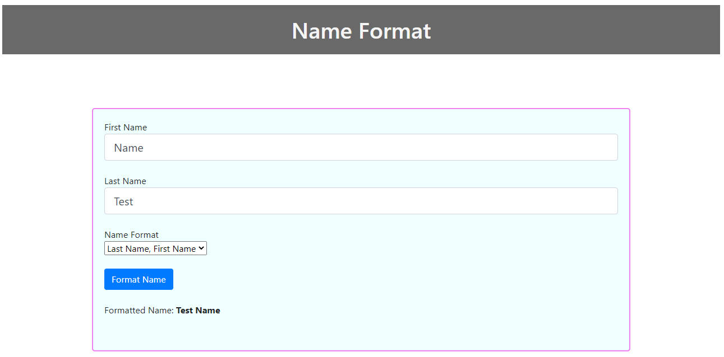

Q9- Create a webpage in which the user inputs something in the text area and the function displays the number of characters in the text area.

Q10- Write a JavaScript code to add validations in the Name, Email, DOB and Select your Interest

Name:

1. Name Textbox have the limit to 50 characters else it will show the error below the text box “Character Limit Exceeds “, when the **Send Details** Button is clicked.
2. If the Name Textbox is empty, it should show an error below the textbox “Name cannot be empty” when the **Send Details** button is clicked.

Email:

1. If the Email Textbox is empty, it should show an error below the textbox “Email cannot be empty” when the **Send Details** button is clicked.
2. Email should have one @ (there should be some test before and after @) else show an error below the textbox “Invalid Email”.

DOB:

1. If the DOB Textbox is empty, it should show an error below the textbox “DOB cannot be empty” when the **Send Details** button is clicked.
2. The User should be 13 years or older else show an error below the textbox “Hello Kid! You are too young for this”.

Select your interest:

1. If the Select your interest Dropdown is not selected, it should show an error below the dropdown “Please select the value to proceed” when the **Send Details** button is clicked.



Use Inline and internal JavaScript and Arrow function for this. Also use try catch in this.

Q11- Create a tax calculator based on these calculations:

* Where the yearly taxable salary income does not exceed Rs. 600,000 the rate of income tax is 0%.
* Where the yearly taxable salary income exceeds Rs. 600,000 but does not exceed Rs. 1,200,000 the rate of income tax is 2.5% of the amount exceeding Rs. 600,000
* Where the yearly taxable salary income exceeds Rs. 1,200,000 but does not exceed Rs. 2,400,000 the rate of income tax is Rs. 15,000+12.5% of the amount exceeding Rs. 1,200,000.
* Where the yearly taxable salary income exceeds Rs. 2,400,000 but does not exceed Rs. 3,600,000 the rate of income tax is Rs. 165,000 + 20% of the amount exceeding Rs. 2,400,000.
* Where the yearly taxable salary income exceeds Rs. 3,600,000 but does not exceed Rs. 6,000,000 the rate of income tax is Rs. 405,000 + 25% of the amount exceeding Rs. 3,600,000.
* Where the yearly taxable salary income exceeds Rs. 6,000,000 but does not exceed Rs. 12,000,000 the rate of income tax is Rs. 1,005,000 + 32.5% of the amount exceeding Rs. 6,000,000.
* Where the yearly taxable salary income exceeds Rs. 12,000,000 the rate of income tax is Rs. 2,955,000 + 35% of the amount exceeding Rs. 12,000,000.

Input the monthly salary and output the monthly taxable amount, monthly salary after tax, yearly tax and yearly income after tax**. No button should be used for calculating the tax, the value should be calculated when the value on the textbox is changed.**

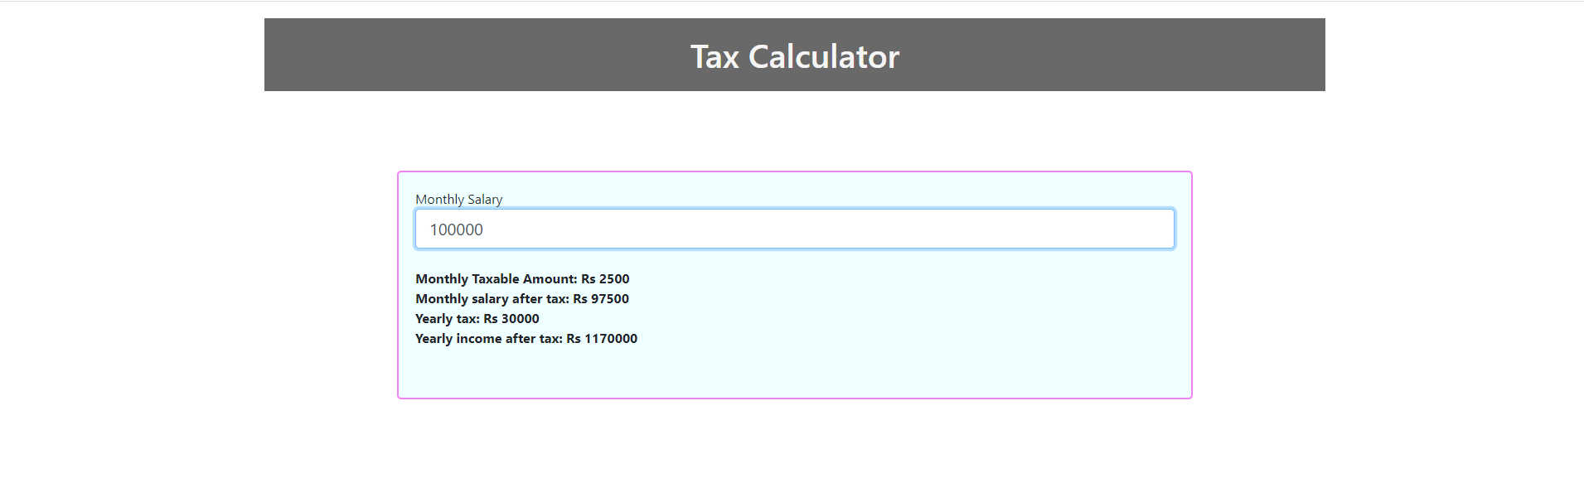

Q12- Create a login page and verify the username and password with the hardcoded values that are already present in the code. If the login is successful, redirect them to another page. Otherwise show them the errors.

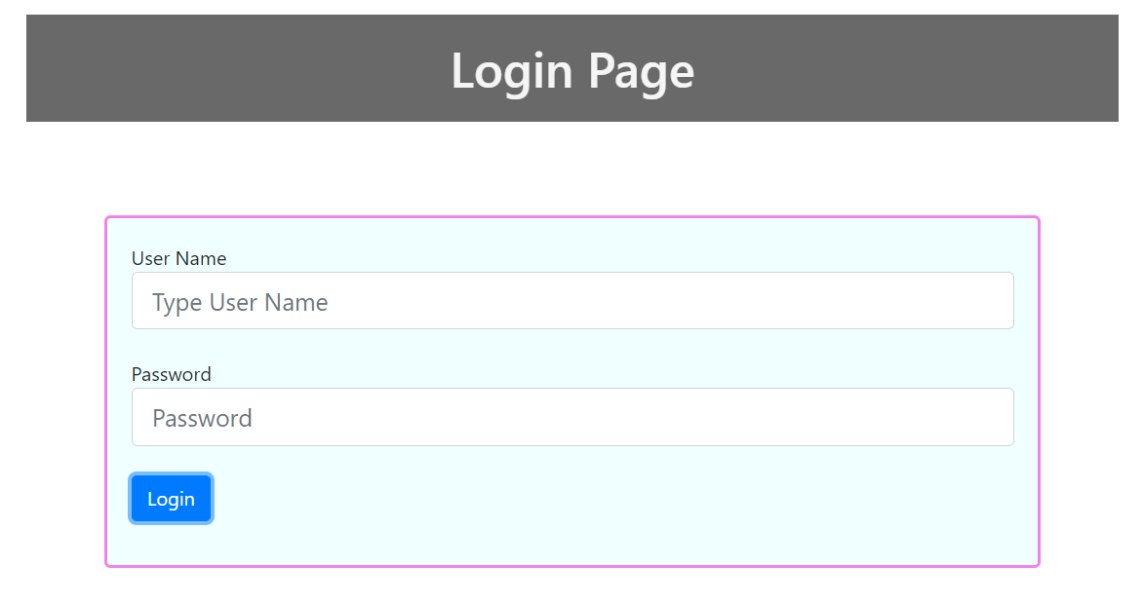

JavaScript Assignment 2

Q13- Set the background color of the p tag when the page is loaded with the help of jQuery.

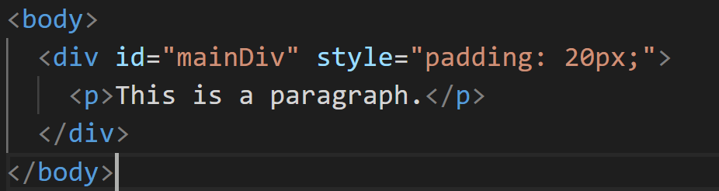

Q14- Create a webpage in which a user adds a text on every click. (use append(), before(), after(), prepend() methods separately)

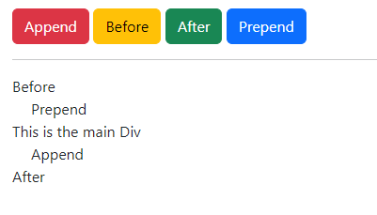

Q15- Remove a div element from the code below.



Q16- Replace all the <p> tag with the <b> tag.

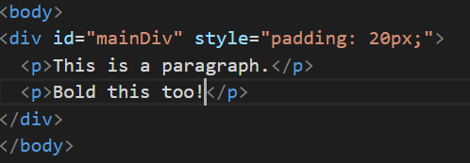

Q17- Wrap all the p tags with em tags.

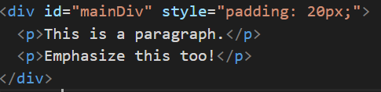

Q18- Create a web page that have 2 drop downs with the same options, if the user selects one value from the dropdown and click enter button, the second dropdown reads the value from the first drop down and automatically selects that value.

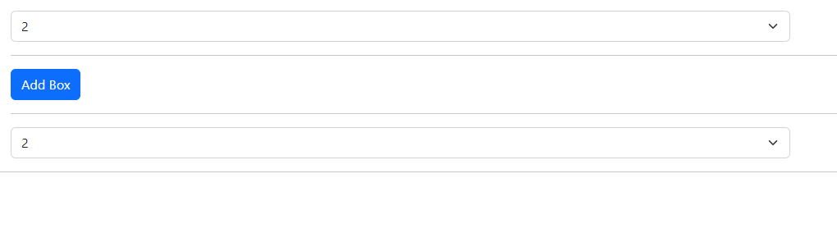

Q19- Show and hide (toggle) a table with the help of a button, a tool tip should be shown when the user hover on the button.

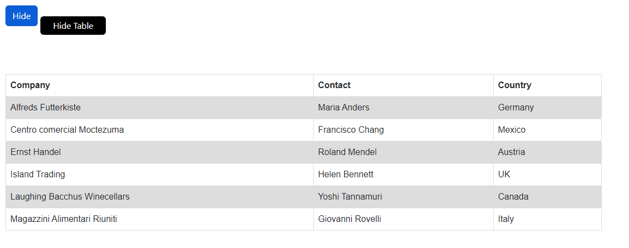



Q20- Create a webpage in which there is a list of names. Each name has a checkbox before them. If the checkbox is clicked and delete button is pressed, that name gets deleted from the list and the next name takes the place of the deleted name. Multiple names can also be deleted by checking multiple checkboxes.

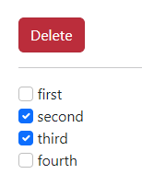 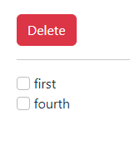

Q21- Create a Web Page in which there are 2 text boxes, there is a checkbox with each textbox. The textbox is enabled only when the checkbox next to it is checked, else the textbox is empty and disabled.



Q22- Create a web page in which a user inputs a name, clicks a button (or presses enter while typing on the textbox) and that name gets printed inside a yellow box (the textbox also empties after clicking the button/pressing enter). The boxes keep on adding when the button is clicked, and the previous box is converted into a dark blue box and text color white (If there is no box before the added box, then there is no need to do this.).

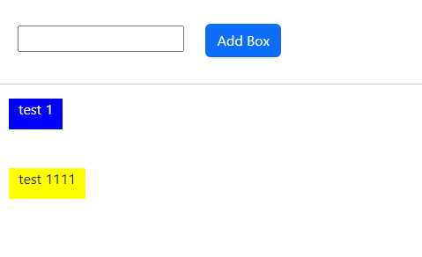

**Added Section**

**Q23.** Create a web-page in which you change the height and width of a div using **animate** on the click of a button. There should be a button to stop the animation at any time (**stop()**) and when you click the change dimensions button again after stopping it should resume the animation. Add another button that will reset it. Use some speed to display the animation.

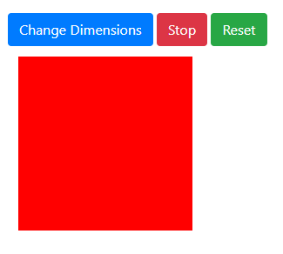

**Q24.** Create a web-page that uses 3 buttons. When you click on the **Fade-In** button the 3 boxes illustrated below gets displayed one after another with some delay plus the boxes should **fade to** some opacity. And when you click **Fade-Out** the three boxes fade out one after another with some delay. The toggle fade button should perform fade-in and fade-out.

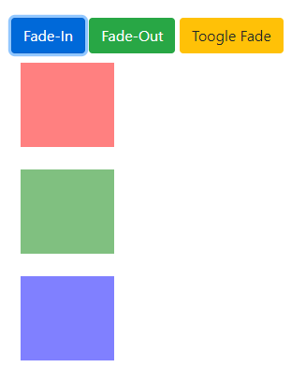

**Q25.** Create a web-page which consist of 3 slide buttons (slide up, slide down, slide toggle).

* When you click slide up, the feedback form slides up and vice versa for the case of slide down.
* Toggle slide should slide up or down the feedback form.
* Use some speed to slide in all cases and after the completion of slide operation whether (slide up, slide down, toggle slide), you must display an alert in callback function. Reference:



* When the submit button is clicked you must do the form validation and after it you should hide the feedback form and show a display button like in figure 2.
* When the show button is clicked it should hide itself and display the feedback form.

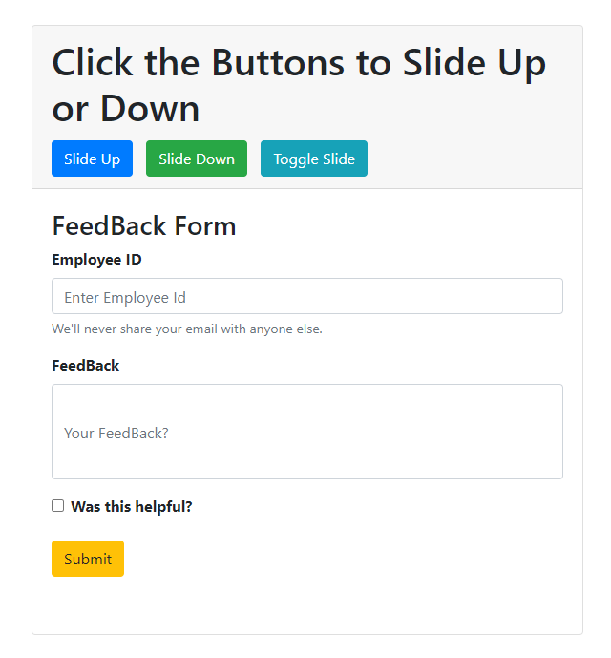

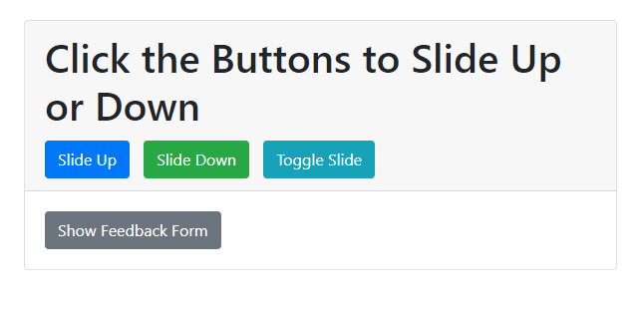

**Q26.** Create a web-page that will consist of 4 buttons as depicted below:

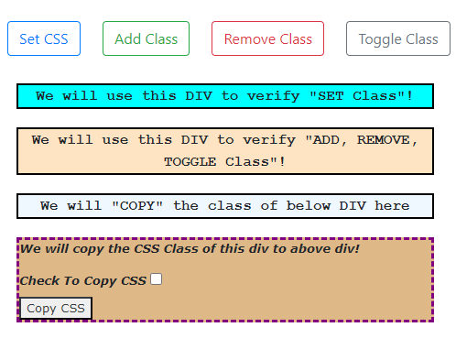

* When we click the Set Class Button the background color of the specified div changes.

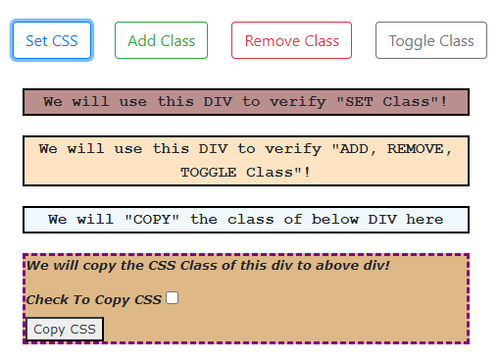

* When you click the Add class, you should add a new class to the specified div.

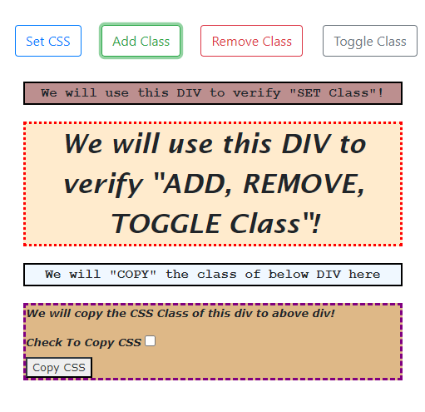

* When you click the remove class, the class added by pressing Add Class Button should get removed.

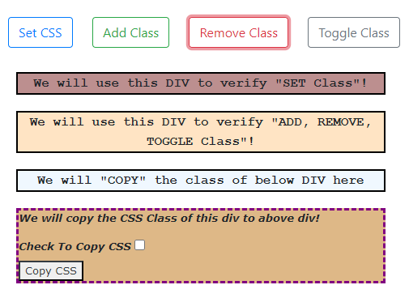

* Toggle Class Button will perform the functionality of Add and Remove Class Button.
* For the next part when you check the checkbox and click the Copy CSS button the CSS of this div should get copied to the above div.

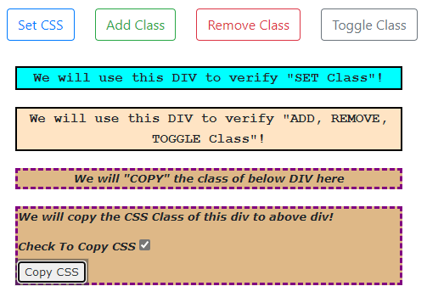

**Q27.** Create a web page using **jQuery UI**. You have to create 6 **Tabs** (**Introduction, Name, Details, Education, Preferences, Confirmation**).

* On **Tab 1** Display some content and a button to move to next tab.

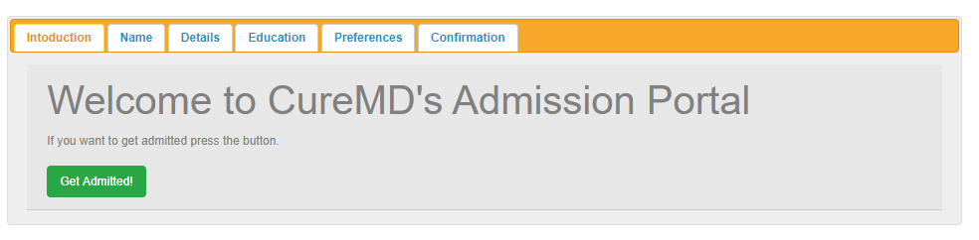

* On **Tab 2** you have to add two text fields and two buttons. One button to move to previous tab and the other to move to next tab.

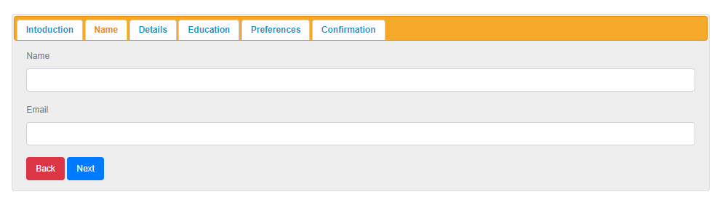

* On **Tab 3** you have to add 3 text field, for DOB input field you will use **DatePicker**. Plus add two buttons as above one to move to previous tab and the other to next tab.

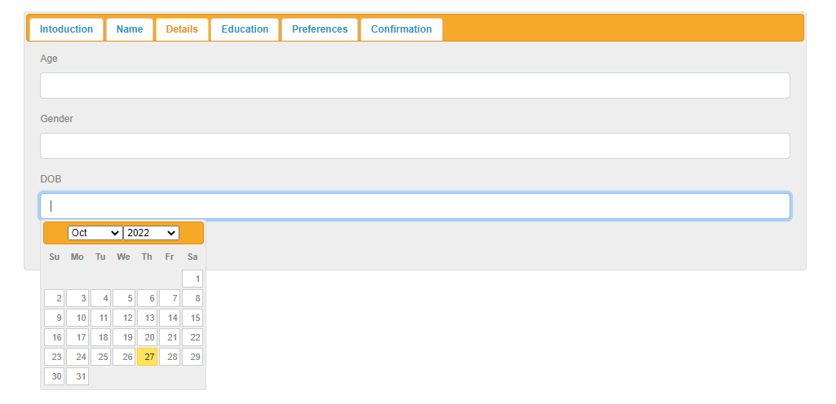

* On **Tab 4** add the same amount of text fields and buttons as in Tab 2.

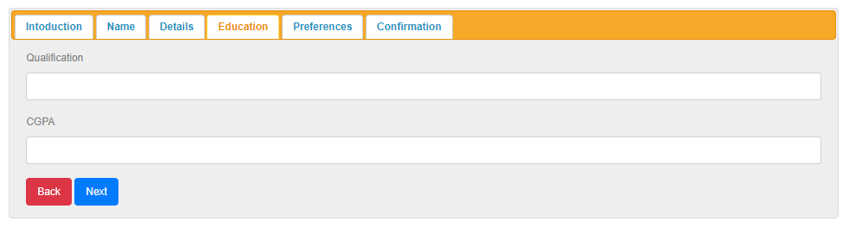

* On **Tab 5** display 4 fields as depicted below using **Sortable.** And when you drag some option you must use an alert to display the text of the option as well as index.

**Before Dragging:**

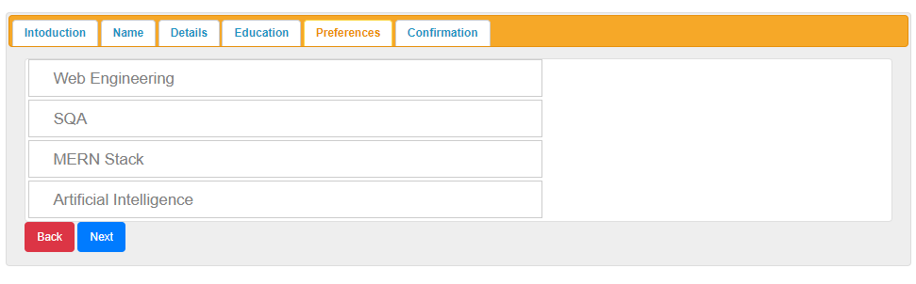

**After Dragging:**

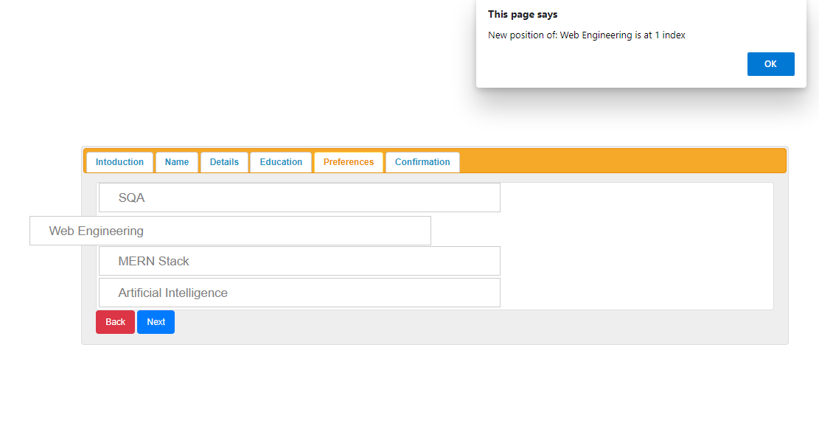

* On **Tab 6** you should ask for the confirmation and by clicking confirm you should display the values of the text field and hide the whole tab.

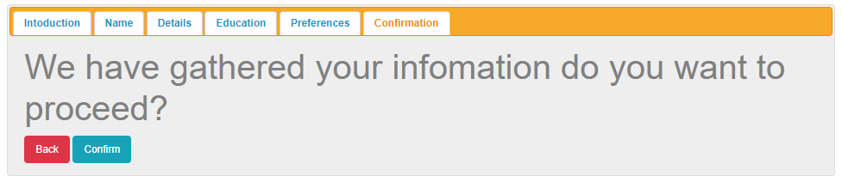

**After Clicking Submit Button**

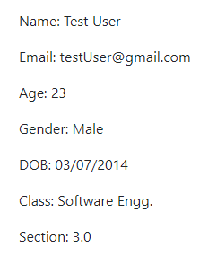

**Q28.** Create a web page that use two date picker fields for getting date and calculate the number of days between them on the click of button. Use **Date Data-type.**

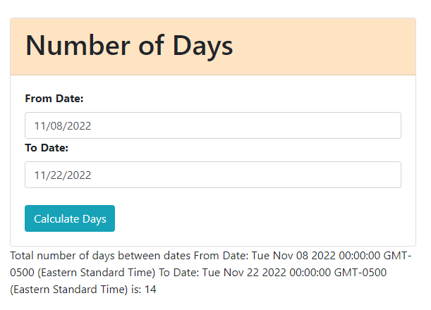

**Note: You have to keep in mind the validations and exception handling where required.**